- 設定HDMI Passthrough mode
  - 遙控器移動到 ”MY” ,如下圖
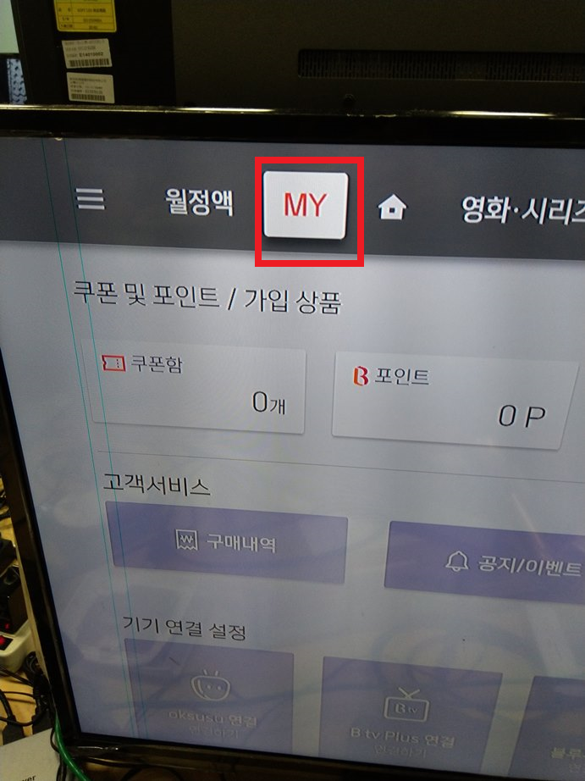
  - 遙控器移動到最下面之後再往右移動如下圖所示
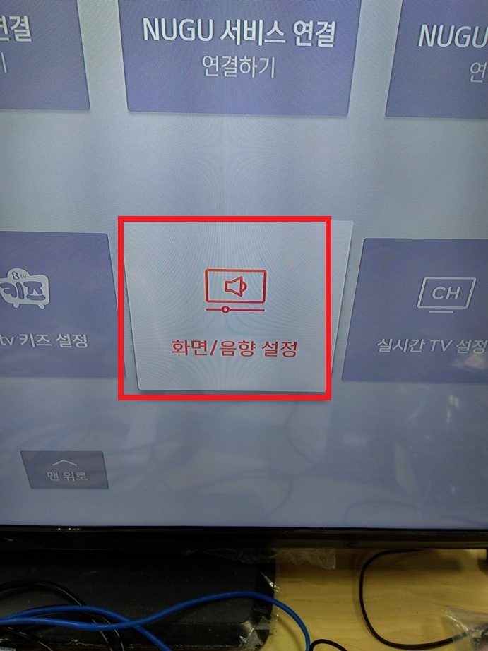
  - 遙控器移動到最右邊並選擇如下圖所示
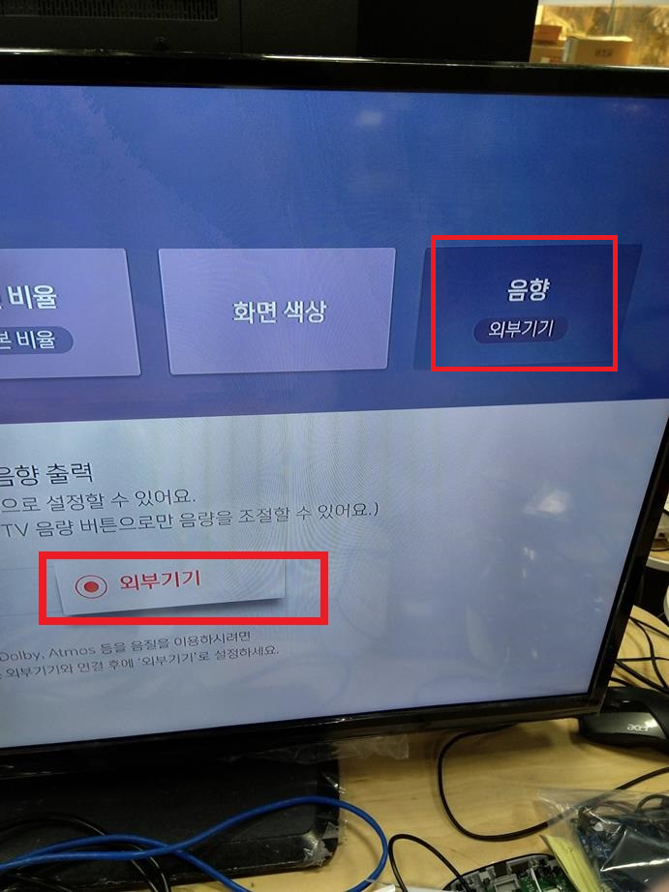

- 安裝VLC
  - 透過adb 安裝VLC apk
    - adb disconnect
    - adb connect 192.168.100.10
    - adb install –r VLC.apk
    - adb shell sync
  - 於UI上執行VLC Player
    - 選擇VLC Player 步驟 1
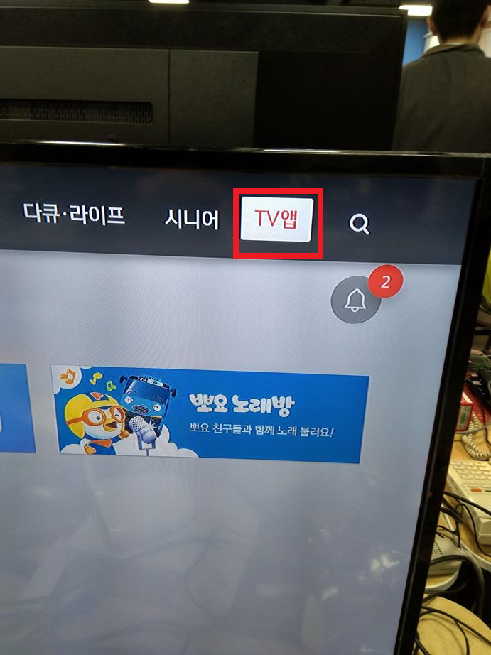
    - 選擇VLC Player 步驟 2
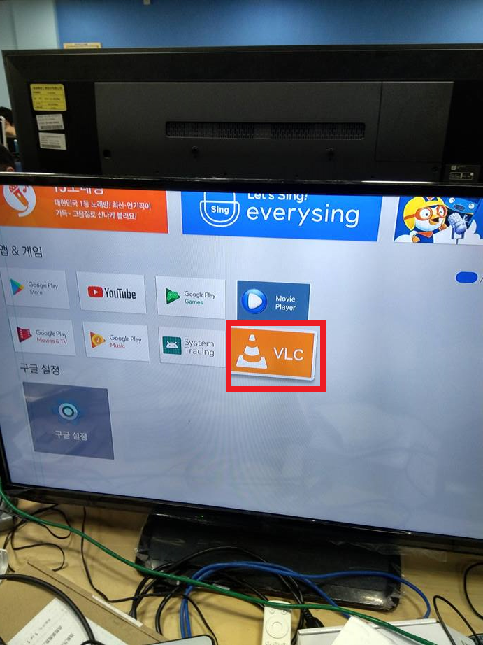

- 播放USB Storage Audio File
  - 選擇播放器步驟 1
  - 選擇播放器步驟 2
