2. BMT 의뢰서
2.1. HW 사양
Chipset | Amlogic S905X2
Flash | eMMC 8GB
DRAM | DDR4 3GB
OS | Android TV "Pie" ver
Video Decoding | H.264 BP/MP/HP@L4.x, H.265 HEVC MP/MP10@L5.1,  VP9, MPEG4, MPEG2, MJPEG
Audio Decoding | AAC, HE-AAC, Dolby Digital Plus  MPEG-1 Audio Layer1, 2, 3  PCM(LPCM / ADPCM)
Bluetooth | BT4.2
Front | 1 X LED (Red/Green/Blue)  1 X IR
TOP | 2 X KEY (CH+/-)
Rear | 1 X HDMI 2.0  1 X 10/100/1000 Base-T Ethernet  1 X DC 5V/2A IN  1 X USB 3.0  1 X MIC Jack
Power Supply | 5V/2A

2.1. 1. Block diagram
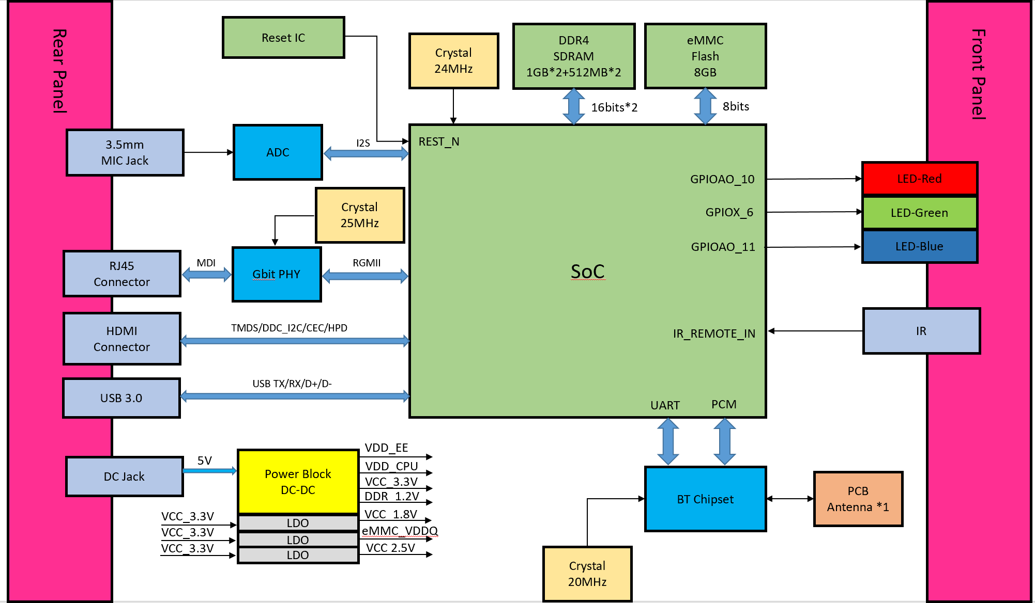

2.1. 2. PCB Assay
a. Set-Top Main Board assy: TOP Side
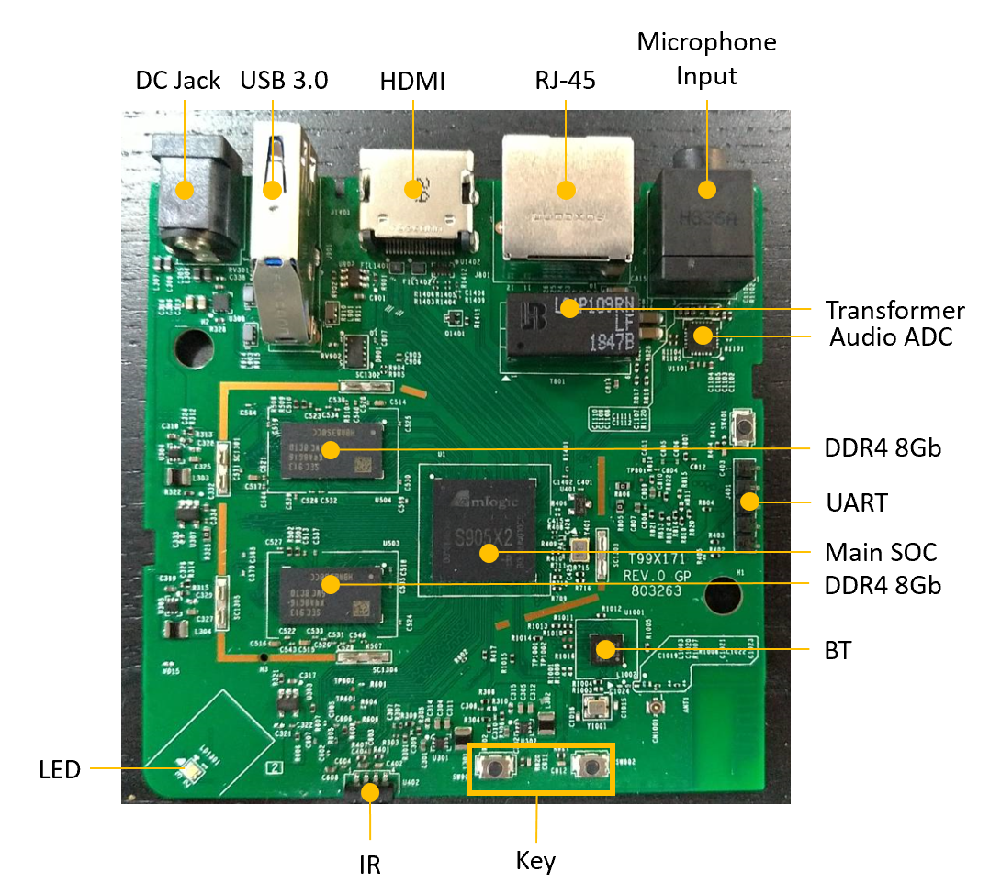

b. Set-Top Main Board assy: BOTTOM Side
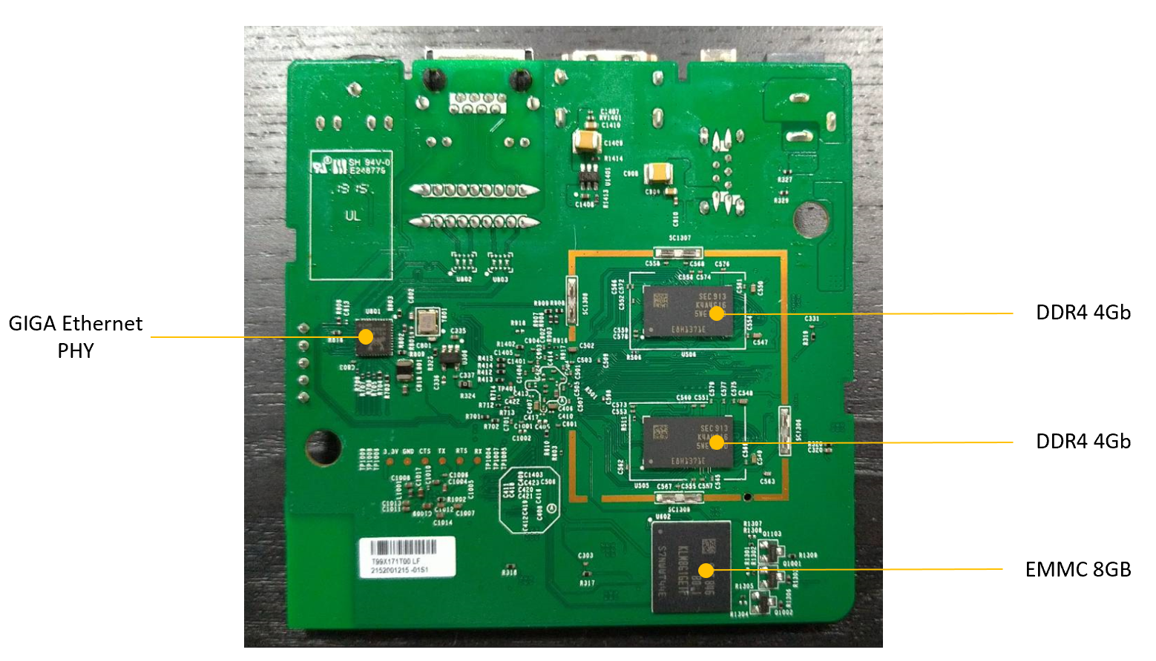

2.1.3. 제품 디자인
(최종 렌더링 이미지는 10/19/금 제출 예정.)
- Front
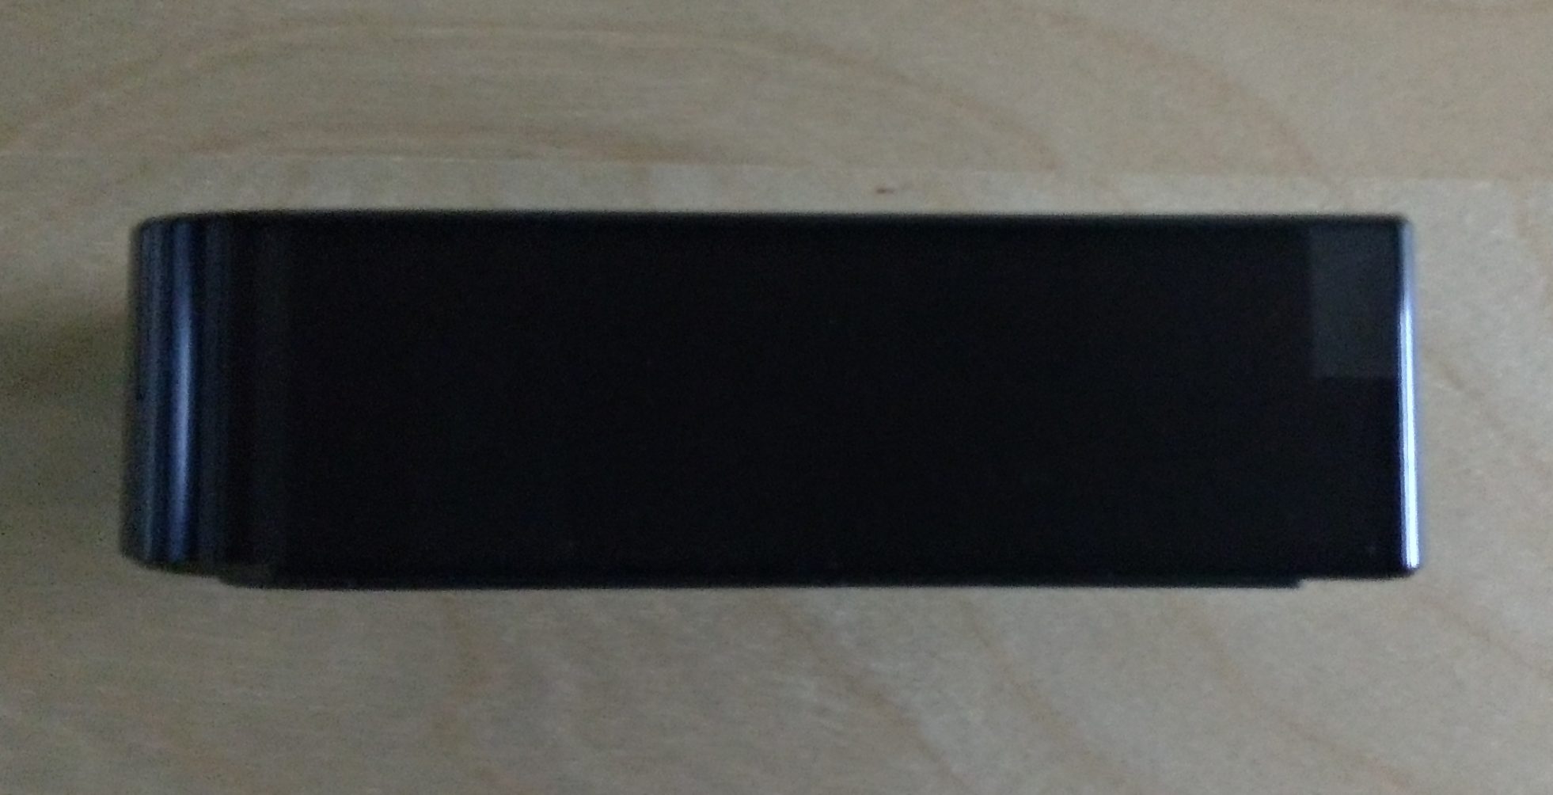
- Rear
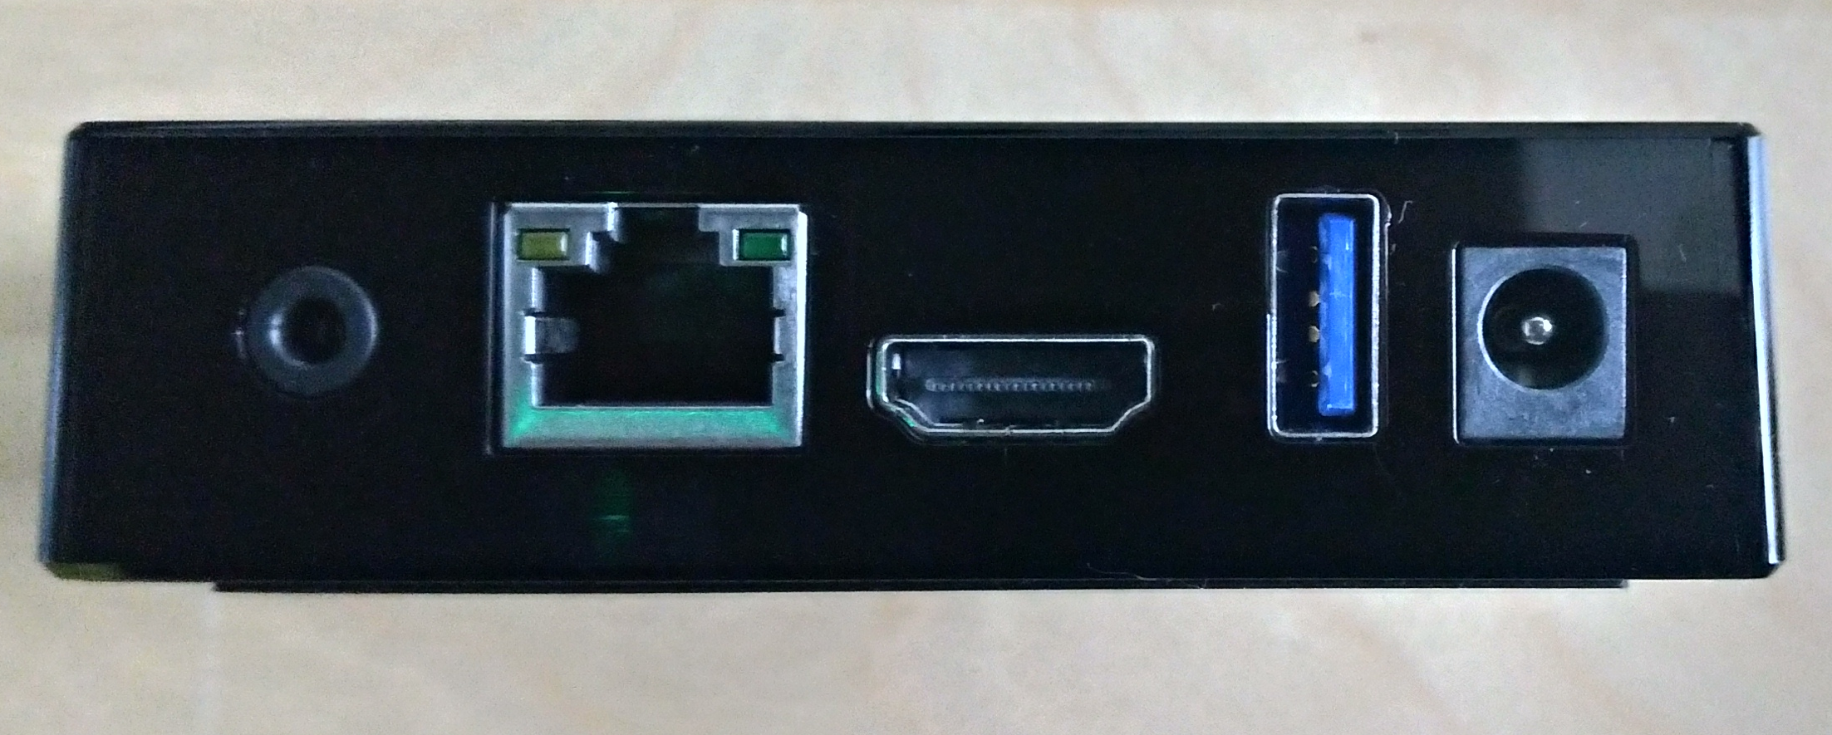
- Left
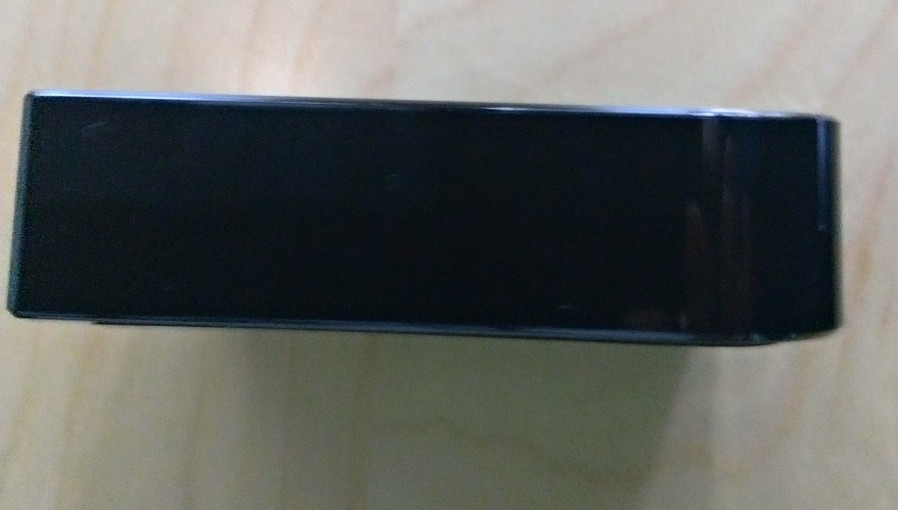
- Right
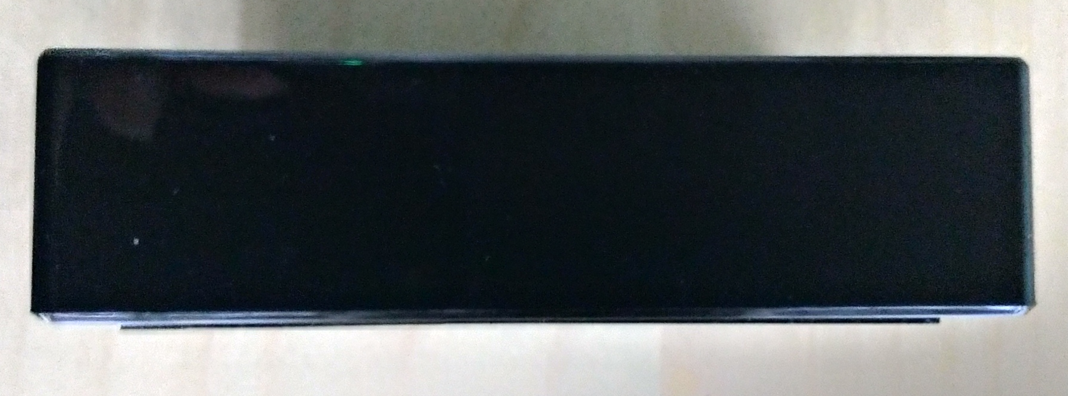

- Top
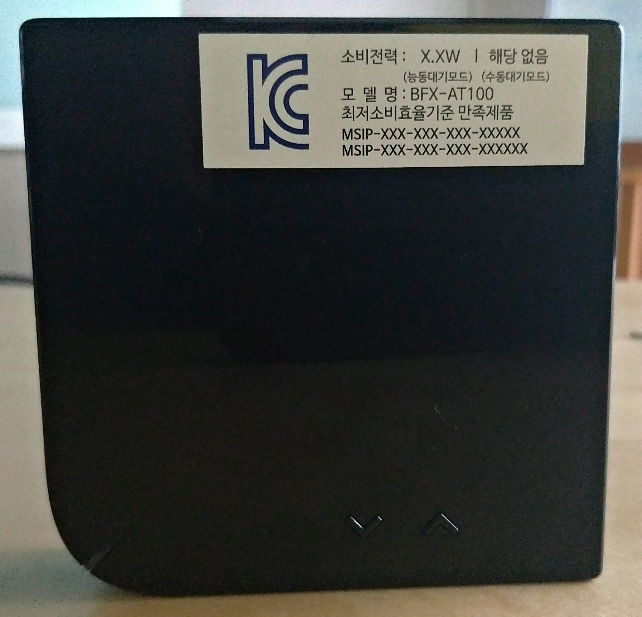

- Bottom
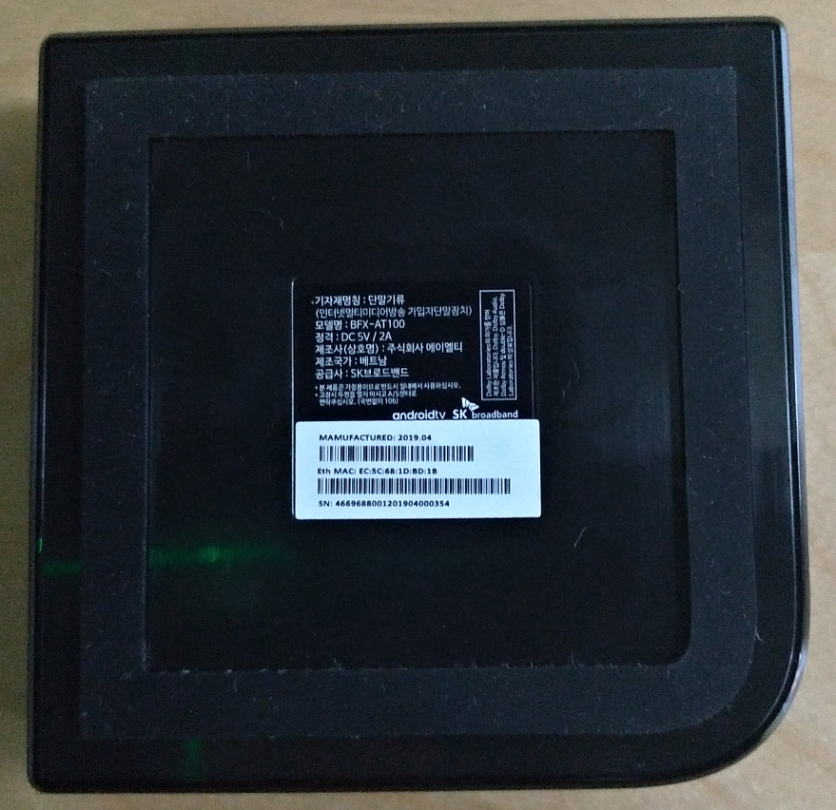

2.1.4. Accessories
-HDMI cable *1
-Cat. 5e LAN cable *1
-User Manual *1
-5V/2A Adapter *1
-IR/BT RCU *1

2.1.5. Main Parts List
Item | PART DESCRIPTION | Quantity
1 | Audio ADC: IC DSP 3.6V SMD QFN24 8~96KHz GP/HF | 1
2 | BT: IC MPU 3.3V SMD FCBGA49 2.4GHz GP/HF | 1
3 | GIGA Ethernet PHY: IC PER 1.5/1.8/2.5/3.3V SMD QFN40 GP ETHERNET TRANSCEIVER | 1
4 | Main SOC: IC PER 1.8/3.3V SMD FCBGA393 GP ARM | 1
5 | DDR4 8Gb: IC DDR4 SDRAM 8Gb 1.2V 0.625nS SMD FBGA96 GP | 2
6 | EMMC 8GB: IC eMMC 8GB 2.7~3.6V 5nS SMD FBGA153 GP | 1
7 | IR: IR RECEIVER 38KHz SMD SMD4 GP | 1
8 | Microphone Input: CONN AUDIO JACK 1*1PORT D=3.6/7.0mm DIP F RT GP | 1
9 | USB 3.0: CONN USB 3.0 A 1*1PORT 2.0mm DIP F RT GP/HF | 1
10 | HDMI: CONN HDMI A 19PIN 1*1PORT 0.5mm SMD MALE RT GP | 1
11 | RJ-45: CONN RJ45 8P8C 1u"GOLD 1*1PORT W/LED Y/G 2.04mm DIP F RT GP BLACK | 1
12 | DDR4 4Gb: IC DDR4 SDRAM 4Gb 1.2V 0.625nS SMD FBGA96 GP | 2
13 | DC Jack: CONN PWR JACK 1*1PORT D=2.0/6.5mm DIP FEMALE RT GP 5V 2A | 1

