SKB Ethernet Test Result v0.1 2019/05/03

- Introduction.
This document specifies the details to validate DUT Ethernet performance. This test will use Iperf3.1.3/Ethtool Test tool and Control NB.

1.1. Auto Negotiation Test
- Test Environment
- Configure the test setup as shown in block diagram below

 Link 
10/100/1000BaseT OTT Box
10/100/1000BaseT NoteBook

Figure 1: Auto Negotiation Test

Purpose: Verify the DUT responds to management by transmitting the
appropriate link signaling.

The performance specified in following paragraphs shall be guaranteed under the following conditions:
Test Items # | Description | Test Status
1 | 1000BaseT – Full duplex | PASS
2 | 1000BaseT – Half duplex | PASS
3 | 100BaseT – Full duplex | PASS
4 | 100BaseT - Half duplex | PASS
5 | 10BaseT – Full duplex | PASS
6 | 10BaseT - Half duplex | PASS

1.2. CRC Error Test
- Test Environment
- Configure the test setup as shown in block diagram below

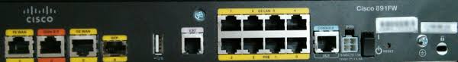
10/100/1000BaseT OTT Box
Notebook
Cisco 891FW

Figure 2: CRC Error Test

The performance specified in following paragraphs shall be guaranteed under the following conditions:
Test Items # | Description | Test Status
1 | 1000BaseT – Full duplex | Fail
2 | 100BaseT – Full duplex | PASS
3 | 10BaseT – Full duplex | PASS

Purpose: Verify the DUT can detect accidental changes to raw data.

- 1000BaseT :
- NB:
To run this test , we will open our command processor and input the following information.
“ iperf3.exe –c 192.168.1.2 –t 3600 –w 90k”
This should look like the following :
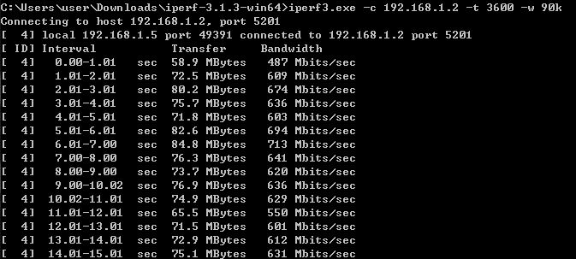
- DUT:
This command will run a iperf test two hours.
“ iperf3.exe –s &”
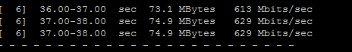

The test results are as follows :
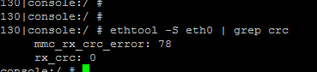

- 100MBaseT :
- NB:
To run this test , we will open our command processor and input the following information.
“ iperf3.exe –c 192.168.1.2 –t 3600 –w 20k”

The test results are as follows :
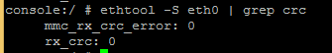

- 10MBaseT :
- NB:
To run this test , we will open our command processor and input the following information.
“ iperf3.exe –c 192.168.1.2 –t 3600 –w 10k”

The test results are as follows :

