Before：
We are measured FFT - (peak)，Returns the FFT magnitude spectrum and displays the results in peak units. But in some cases, it is not very stable.

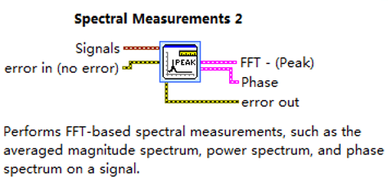

Now:
The update is to change to power spectrum measurement and verify a batch of golden samples (non-pushing/little gap/pass), it seems more suitable for this test.
